MODULE 3: Inheritance
Contents
Inheritance 1
Some Important Concepts of Inheritance 2
Advantages of Inheritance 5
Disadvantages of Inheritance 5
Design Patterns 6
Iterator Pattern 7

Inheritance
Inheritance in Java is a mechanism where one class (subclass/child class) acquires the properties and behaviors (fields and methods) of another class (superclass/parent class). It promotes code reusability and establishes a parent-child relationship between the classes. By using inheritance, a subclass can extend or modify the existing behavior of a superclass, making the code more modular and easier to maintain.
- The extends keyword is used to define inheritance between classes. When one class extends another, the subclass inherits the properties and methods of the superclass.
- Super Class: Also known as the parent class, it is the class from which other classes inherit. It contains common fields and methods that are shared by all subclasses.
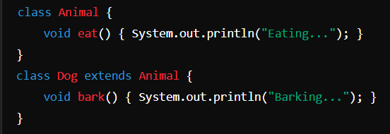
- Sub Class: Also known as the child class, it is the class that inherits from the super class. The subclass can access and reuse the methods and fields of the superclass. It can also override or extend the superclass’s functionality.
Types of Inheritance in Java
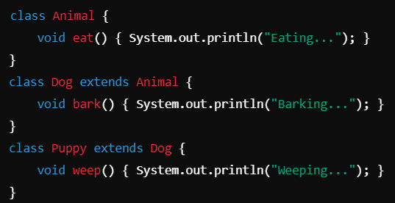
a) Single Inheritance: a subclass inherits from a single superclass. This is the most basic form of inheritance where one class extends another.

b) Multilevel Inheritance: a class is derived from another subclass. This forms a chain of inheritance where a subclass further extends a class that has already inherited from another class.

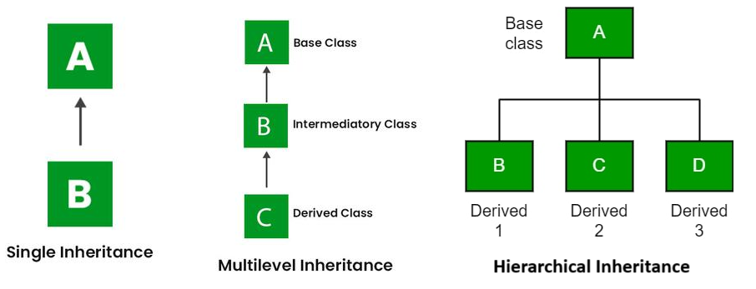
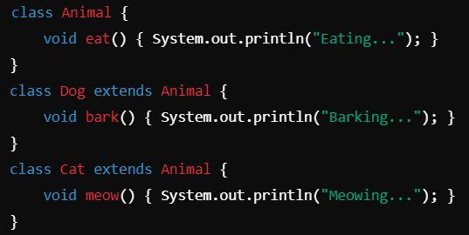
b) Hierarchical Inheritance: multiple subclasses inherit from the same superclass. This allows different subclasses to share the behavior of a common superclass.

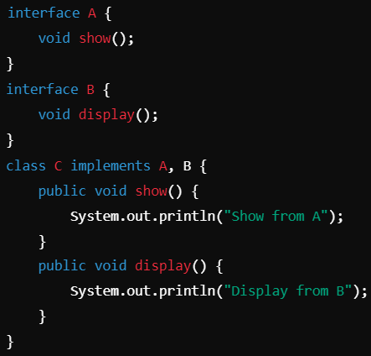
Some Important Concepts of Inheritance
  - Multiple Inheritance (Not Supported in Java): Java does not support multiple inheritance directly, where a class can inherit from more than one class. This limitation avoids ambiguity caused by conflicts from inheriting the same method from multiple classes. However, Java achieves multiple inheritance via interfaces.

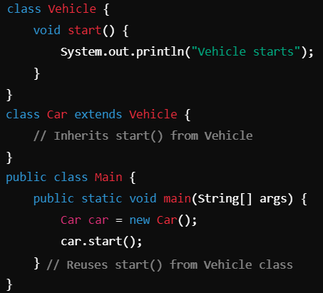
  - Code Reusability through Inheritance: Inheritance promotes code reusability by allowing a subclass to inherit properties and methods from a superclass. Instead of writing the same code repeatedly, you can define it once in the superclass and have all subclasses use or override it. This reduces redundancy and improves maintainability.
Here, the Car class reuses the start() method from the Vehicle class without redefining it.

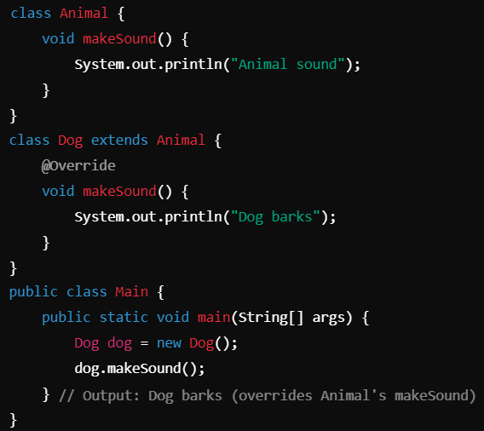
  - Method Overriding in Inheritance: Method Overriding occurs when a subclass provides its own implementation of a method that is already defined in the superclass. The overridden method in the subclass has the same signature (method name and parameters) as the method in the superclass. It allows a subclass to customize or extend the behavior of the inherited method.
In this example, Dog overrides the makeSound() method of the Animal class to provide specific behavior.

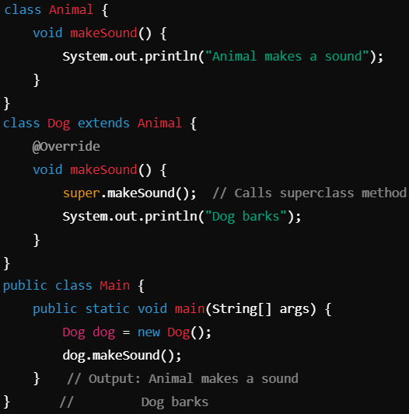
  - Super Keyword and its Usage in Inheritance: The super keyword in Java refers to the immediate superclass of the current object. It is used to access superclass methods, fields, and constructors, especially when the subclass has overridden methods or constructors.
    - Accessing Superclass Methods: The super keyword can be used to call a method from the superclass when it is overridden by the subclass. In this case, super.makeSound() invokes the method from the Animal class, even though Dog overrides it.
In this case, super.makeSound() invokes the method from the Animal class, even though Dog overrides it.
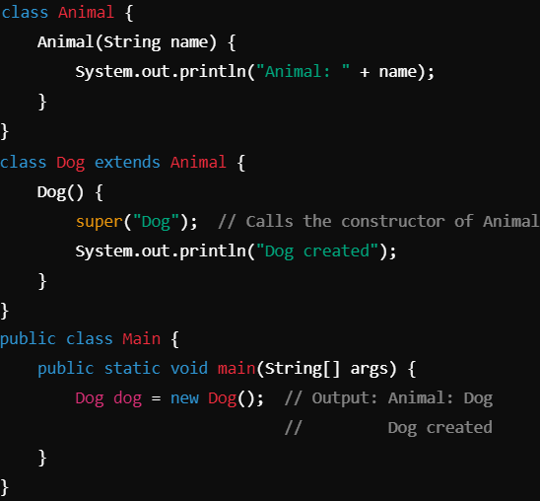
    - Accessing Superclass Constructors: The super keyword can also be used to call the constructor of the superclass when a subclass constructor is executed. This is useful when the superclass constructor requires parameters.
Here, super("Dog") calls the constructor of the Animal class from the Dog constructor.

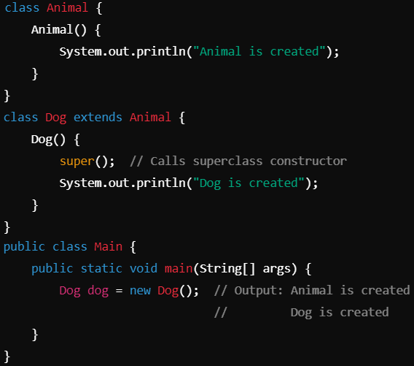
  - Constructor Chaining: refers to the process of invoking one constructor from another within the same class or across different classes using this() or super().
- In the same class, constructor chaining is done using the this() keyword to call another constructor.
- In inheritance, constructor chaining is done using super() to call the parent class’s constructor.
- The chain starts from the current class constructor and proceeds upwards through the class hierarchy. Every subclass constructor implicitly or explicitly calls the constructor of its superclass.
- In this example, when the Dog constructor is called, the Animal constructor is also invoked because of super(). This ensures that the object is initialized from the top of the hierarchy downwards.

  - Final Keyword in Inheritance
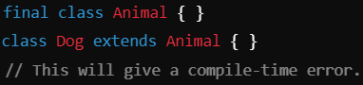
    - Preventing Inheritance with final Class: When a class is declared with the final keyword, it cannot be inherited by any subclass. For example:
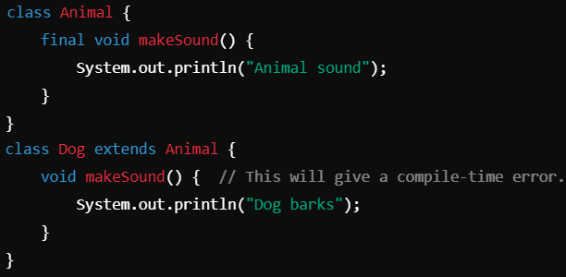
    - Preventing Method Overriding with final Methods: A method declared as final cannot be overridden by any subclass. For example:

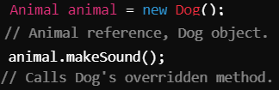
  - Polymorphism in Inheritance: Polymorphism allows the subclass to define its own behavior while inheriting the parent class’s properties. A parent class reference can refer to a child class object, providing flexible code that works with different types of objects.
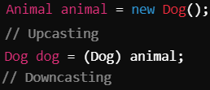
  - Upcasting and Downcasting in Inheritance
- Upcasting: Casting a subclass object to its superclass type. This is done automatically in Java.
- Downcasting: Casting a superclass reference back to a subclass type. It needs to be done manually and checked at runtime to avoid ClassCastException.

Advantages of Inheritance
- Code Reusability: Allows reuse of existing code, reducing redundancy by inheriting fields and methods from a superclass.
- Method Overriding: Enables subclass-specific implementations of methods, enhancing flexibility.
- Polymorphism: Facilitates dynamic method dispatch, allowing different implementations for a single method call.
- Simplifies Maintenance: Changes made in the parent class are reflected in all child classes, making maintenance easier.
- Encourages Modular Design: Promotes cleaner and more modular code organization through hierarchical structures.
- Supports Extensibility: Enables adding new functionalities to existing code without modifying it directly.
- Consistency: Helps maintain consistency across similar types of objects by sharing common functionality.
- Faster Development: Reduces development time by leveraging existing, well-tested code.
- Reduces Duplication: Prevents code duplication by inheriting common attributes and behaviors.
- Promotes Scalability: Makes it easier to scale applications as new subclasses can be created to extend existing functionality.

Disadvantages of Inheritance
- Tight Coupling: Creates strong dependency between parent and child classes, making the system more rigid.
- Fragile Base Class Problem: Changes in the base class can inadvertently break the functionality of child classes.
- Reduced Flexibility: Forces an "is-a" relationship, which may not always fit the actual design requirement.
- Inheritance Misuse: Can lead to improper design when used only for code reuse instead of representing a true relationship.
- Performance Overhead: Can slow down performance due to deep inheritance hierarchies and method resolution.
- Complexity: Introduces unnecessary complexity when simple composition would suffice.
- Limited Modifications: Modifying the parent class affects all subclasses, which may not always be desirable.
- Difficulty in Testing: Unit testing becomes more challenging due to dependencies between parent and child classes.
- Restricted Multiple Inheritance: Java doesn't support multiple inheritance of classes, limiting design flexibility.
- Lack of Control: Subclasses have access to all public and protected members of the parent class, which can be misused.

Design Patterns
Design patterns are proven, reusable solutions to common software design problems, providing a structured way to address recurring challenges. Purpose:
- Simplify complex software design.
- Enhance code reusability, readability, and maintainability.
- Promote best practices and improve system scalability.
- Encourage use of object-oriented principles like encapsulation and polymorphism.

Categories of Design Patterns
1. Creational Patterns: Focus on ways to create objects while hiding the creation logic, ensuring flexibility and decoupling in object creation. Examples:
  - Singleton: Ensures only one instance of a class exists and provides global access to it. Commonly used for logging, configuration management, or database connections.
  - Factory: Abstracts object creation by returning instances based on input parameters or conditions. Example: Shape Factory (getShape() returns Circle, Square, etc.).
  - Builder: Constructs complex objects step-by-step using a series of methods. Used when objects have multiple optional components (e.g., building a Car with optional parts).

2. Structural Patterns: Focus on the composition of objects and classes to form larger structures while maintaining flexibility and efficiency. Examples:
- Adapter: Converts one interface to another, enabling incompatible systems to work together. Example: Adapting legacy system APIs to modern interfaces.
- Composite: Treats individual objects and groups of objects uniformly. Example: File system representation (Files and Folders treated similarly).
- Decorator: Dynamically adds functionality to objects without modifying their code. Example: Adding formatting options to a text editor (bold, italic).

3. Behavioural Patterns: Focus on interactions and communication between objects, defining how objects collaborate to achieve complex tasks. Examples:
- Observer: Implements publish-subscribe, where changes in one object notify multiple subscribers. Example: News subscriptions or event listeners.
- Strategy: Allows dynamic switching of algorithms at runtime. Example: Choosing different payment methods in an e-commerce app.
- Command: Encapsulates a request as an object, allowing for parameterization, queuing, and undo/redo functionality. Example: Implementing a remote control system for devices.

Benefits of Design Patterns
- Promotes code reusability and maintainability.
- Encourages the use of best practices.
- Enhances collaboration and understanding between developers by providing a standard design vocabulary.
- Simplifies scalability and adaptability in system design.

Iterator Pattern
The Iterator Pattern is a behavioural design pattern that provides a way to access elements of a collection sequentially without exposing the collection’s internal structure. Purpose:
- To allow traversal of a collection (e.g., lists, sets) without needing to know its internal representation.
- It decouples the logic for accessing elements from the collection's implementation.
- Useful for working with different types of collections in a uniform way.

Aspect | Iterator | Iterable
Definition | An interface used to traverse elements in a collection. | An interface that represents a collection capable of returning an Iterator.
Key Methods | hasNext(), next(), remove() | iterator()
Responsibility | Provides logic for iterating through elements. | Ensures that the collection can produce an Iterator.
Return Type | Does not return itself. | Returns an Iterator instance.
Usage | Used for actual iteration. | Acts as a wrapper for iteration support.
Example | Iterator<String> it = list.iterator(); | class MyCollection implements Iterable {}

Java’s Collection Framework Implementation of Iterators
- List: Collections like ArrayList, LinkedList implement Iterator for sequential traversal. Supports ListIterator for bidirectional traversal.
- Set: Classes like HashSet and TreeSet use Iterator for unordered traversal.
- Map: Does not directly implement Iterator. Uses keySet(), values(), or entrySet() to create iterators for keys, values, or key-value pairs.
- Queue: Classes like PriorityQueue and LinkedBlockingQueue provide Iterator implementations to traverse elements.
- Fail-Fast Behavior: Most iterators in Java are fail-fast, meaning they throw a ConcurrentModificationException if the collection is modified during iteration.

